Solve the given problems and show your complete solution (3 points each).

1. When $x^{4}+Rx^{3}+Px^{2}-32x+64$ is divided by $x-1,$ the remainder is 45. When divided by $x-4,$ the remainder is 0. Find $R$ and $P.$

$$Answer: R = -8, P = 20$$

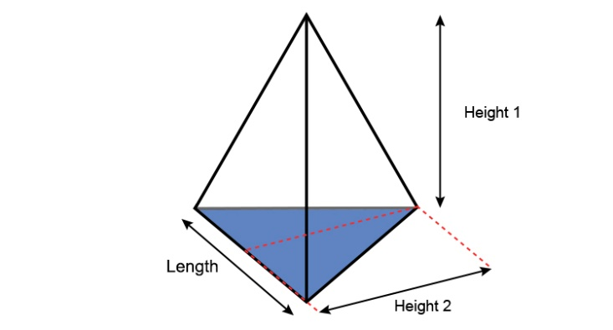

Altitude

1. Find the height of a triangular-based pyramid, including the length and altitude of the base if the volume of the pyramid is $36$ cubic feet and the length of the base is 3 less than twice the height and the altitude is 2 less than the height.
$$Answer:h=6ft, l=9ft, a=4ft$$

2. A ball was thrown upward with initial velocity of $20m/s$ from the ground. If the acceleration of gravity is $10m/s^{2}$,
3. what is the maximum height? Answer: 20m
4. after how many seconds will it reach the height of 15m? Answer: 1 sec and 3 seconds
5. A class trip with a fixed cost of $\$6000$ will be evenly divided to the number of attendees. If there had been 10 more attendees, the cost per attendee would be $\$30$ less. How many joined the trip?

Answer: $40 attendees$

Challenge Problem

1. Find the height of a triangular-based pyramid, including the length of the three sides of the base if the volume of the pyramid is $16\sqrt{6}$ cubic feet and the length of the three sides of the base are 3 less than the height, 2 less than the height, and three more than half the height.

b

a

height

c

$$Answer:h=8ft, a=5ft, b=6ft, c=7ft$$